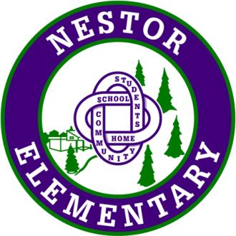  École Nestor Elementary School | 1266 Nestor Street, Coquitlam, B.C. V3E 2A4  604-464-9422 Fax - 604-937-8028  Website: www.sd43.bc.ca/school/nestor

Welcome Back to School September 2018!

​(Important information for Nestor and New to Nestor students)

The New School Year
The new school year begins on Tuesday, September 4th at 8:50 a.m. The children grade 1 – 5 will be with us for only a short time (no later than 9:30 a.m.) on this date while we confirm attendance numbers and class sizes. On the first day each child must report to the classroom that he/she was in this year. All students new to the school who have already registered will report to the library. If you have not yet registered your child, please go to the office. New Kindergarten students will attend Tuesday, September 4th from 10:00-10:30am.
Grades 1 – 5 first regular day of attendance (8:50-2:45) will be on Wednesday, September 5th.
September 5 – 7th will focus on community building events and activities. Please make sure your child has a pencil and crayons to work with along with a recess snack and lunch. Students do not need to bring all their school supplies this week. School supplies ordered through Creative Children will be available for pick up later in the week. Please make sure your child is dressed for rainy weather as we plan many activities and breaks outside.
September 17th will be the 1st full day for Kindergarten.
September 18th Parent Information Night 7 – 8pm in the gym.
September 19th – 20th Early dismissal 1:30pm / Welcoming Conversations for all parents of grades 1 – 5 students
September 21st District Pro-d Day
September 27th Terry Fox Run
This is the school wide calendar for September, individual classes may have additional plans

WELCOMING CONVERSATIONS FOR GRADE 1-5 STUDENTS
SEPTEMBER 19TH and 20TH, 2018
During the week of September 10th, teachers will be sending home a notice, offering meeting times and requesting some information for our “Welcoming Conversations” that will be taking place on September 19th and 20th. A Welcoming Conversation is a very important meeting with your child’s teacher, designed to provide you with the opportunity to get to know your child’s teacher, become familiar with classroom routines and expectations, as well as ask clarifying questions. It is extremely important for at least one parent to make time on one of the 2 days to meet and be part of the conversation. Meetings will be taking place between 1:30 pm and 5:00 pm on September 19th and 20th.
Ms. Calla (Counselling), Ms. Ritchie (Resource), Mrs. Elson (Learning Assistance), Ms. Danielle (ELL), Mrs. Kiddie (Music), Mme. Poirier (FI Learning Assistance) and Mrs. Coyle (Teacher Librarian) and Mrs. Banks will be available during the afternoons as well.
Students will be dismissed at 1:30 pm each day. We will be providing activities in the gym and music room for students whose parents are in Welcoming Conversations meetings between 1:30-2:45. If your scheduled time is after 2:45 p.m., please make necessary arrangements for your children.
We greatly look forward to meeting and talking with you. Thank you for supporting your child’s educational journey.
A detailed calendar for the 2018-19 school year (including holidays and pro-d days) can be found right on our web-site at www.sd43.bc.ca/school/nestor
Happy New School Year!

Tamara Banks
Principal

